**How to resolve unknown host name for the secure agent in Linux.**

1. Execute the command "hostname -f" on secure agent machine to verify the host name of the server.

2. Manually add an entry to /etc/hostname or **/etc/hosts** file for hostname resolution. <ipAddress of the server> <HostName>

3. Shut down the secure agent

sudo /opt/infaagent/apps/agentcore/infaagent shutdown

4. Go to path {Agent.Dir}\main and open the file infaagent.ini

You can run the linux command below to find the infaagent.ini

Find -name infaagent.ini

When you find the multiple files, make sure to edit the latest version. In the example below, 27.0.16 is the latest.

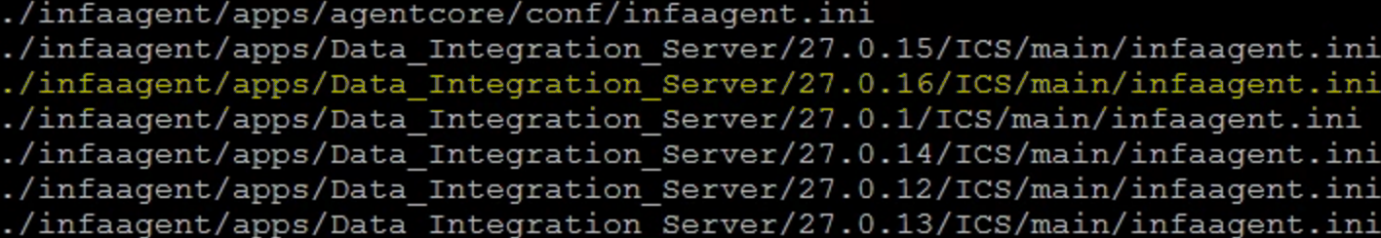

5. Remove all the entries in the file except:

    InfaAgent.MasterUrl=<https://app.informaticaondemand.com/ma>;

   The only entry in the file should be: InfaAgent.MasterUrl=<https://app.informaticaondemand.com/ma>

6. Save the file and restart the agent.

sudo /opt/infaagent/apps/agentcore/infaagent startup

You may need to re-configure agent if the startup command doesn’t work.

sudo /opt/infaagent/apps/agentcore/consoleAgentManager.sh configure <User Name> <Password>

Other useful command

To check the status of the agent

sudo /opt/infaagent/apps/agentcore/consoleAgentManager.sh getStatus

To check if the agent is configured

sudo /opt/infaagent/apps/agentcore/consoleAgentManager.sh isConfigured